CSA0501-DATABASE MANAGEMENT SYSTEMS
LAB EXPERIMENTS DATE: 28/07/2026

EXPERIMENT 12 -- Simple Programming using REPEAT, WHILE

AIM:
To learn how to use MySQL loop statements (WHILE and REPEAT) in the Flight Reservation System database.

PROCEDURE:
1. Open MySQL Workbench and select the Flight_Reservation database.
2. Create a stored procedure using the WHILE loop.
3. Execute the procedure and verify the output.
4. Create another stored procedure using the REPEAT loop.
5. Execute the procedure and verify the output.
6. Observe the results.

PROGRAM:

Program - 1 (WHILE Loop)
Display Passenger IDs from 101 to 105 using a WHILE loop.
DELIMITER //
CREATE PROCEDURE Display_PassengerIDs()
BEGIN
DECLARE x INT DEFAULT 101;
WHILE x <= 105 DO
SELECT x AS Passenger_ID;
SET x = x + 1;
END WHILE;
END //
DELIMITER ;
CALL Display_PassengerIDs();
OUTPUT:
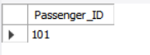
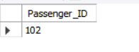
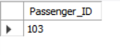
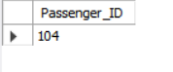
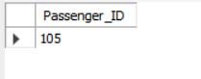
Program - 2 (REPEAT Loop)
Increase the ticket amount until it becomes greater than or equal to 8000.
DELIMITER //
CREATE PROCEDURE Ticket_Amount()
BEGIN
DECLARE amount DECIMAL(10,2) DEFAULT 5000;
REPEAT
SET amount = amount + 500;
UNTIL amount >= 8000
END REPEAT;
SELECT amount AS Final_Amount;
END //
DELIMITER ;
CALL Ticket_Amount();
OUTPUT:

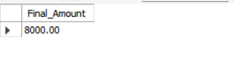

RESULT:
Thus, the simple programming exercises using WHILE and REPEAT loops were successfully executed in the Flight Reservation System database.

